SYNTHESIS, CHARACTERIZATION AND ANTIMICROBIAL STUDIES OF GEMINAL AND NON-GEMINAL AMINO DERIVATIVES OF HEXACHLORO CYCLO TRIPHOSPHAZENE
Safaa A. Ahmed
Department of Chemistry, College of Education, University of Samarra, Iraq.
E-mail: drsafaa1954@yahoo.com
ABSTRACT: The reaction of hexachloro cyclo triphosphazene (1) with 1,2-diamin phenyl in mole ratio 1:3 was studied. New geminally substituted phosphazene derivatives 4,4,6,6- tetra anilido-2,2-bis-(1,2 diamido phenyl) cyclo triphosphazene (4) were obtained from the reaction of tetrachloro bis-(1,2-diamido cyclo triphosphazene (1) with aniline in presence of triethylamin at -80°C as HCl acceptor. 6,6-dianilido-2,2,4 di(1,2diamidophenyl) cyclo triphosphazene (5) was synthesized from the reaction of (3) with aniline and triethylamine. A non germinal substituted phosphazene derivative, 4,4,6,6,1-pentachloro mono(saccharino) cyclo triphosphazene was obtained from the reaction of (1) with saccharin in presence of triethylamin in acetone at – 60°C, in mole ratio 1:3. 4,4,6,6,1-pentachloro mono (2-amino pyridine) cyclo triphosphazene and 1,4,6-trichloro–1,4,6 tri (2–amido pyridine) cyclo phosphazene was synthesized by the reaction of (1) with 2-amino pyridine in presence of triethylamin in acetone at - 60°C. The structures of the prepared compounds were characterized by elemental analyses, FT-IR, ¹H, ¹³C, ³¹PNMR specroscopy and were tested for their antimicrobial potential.

Key words: geminal, non geminal, amino derivatives, antimicrobial activity, triphosphazene, cyclotriphosphazene.

- INTRODUCTION

Schiff bases represent one of the most widely used families. The full or partial preparation of amido cyclo phosphazene was written very early [1-10], as shown below.

Phosphazenes, are compounds having -P=N- group in their molecules which considered as an important class of compounds in the chemistry of phosphorus and nitrogen.
First heterocyclic compound of the composition (PNCl₂)₃ and (PNCl₂)₄ were isolated in the 1830(s) [11-13] from the reaction of PCl₅ with NH₄Cl. Since that time, adiverse class of phosphazene ring and linear species has been investigated [14-17]. Hexachlorocyclo triphosphazene, P₃N₃Cl₆, being easily prepared, is commonly used as a starting materials for many subustitutions [18]. They also possess a number of characteristics such as fertilizer polymer, fire retardant and anti microbial activity [19-23].
Hexachlorocyclo triphosphazene reacts with amino derivatives in different mole ratios to form geminal and non geminal amido phosphazene [24,25]. Within the context of biological and pharmacological properties of some amido and amino phosphazenes, a lone electron per of the reagent nitrogen atom attacks a phosphorus atom of the phosphazene cycle, and amido or amino cyclo triphosphazene derivatives are formed under release of HCl [2,3].
The results of the reaction of phosphazene derivatives with a nucleophile reagent strongly depends on the reaction conditions whereas a series of various substitution derivatives can be formed [26-31].
Phosphazenes possess a number of characteristics such as used as drug components for the chemotherapeutic applications and antibacterial activity [32,33]. These compounds are used in the substructure of medical implantes and drug delivery systems. Phosphazene compounds and their derivatives are widely used against bacterial agents in medicine to provide surface cover in cardiovascular devices, knee and hip joints and acularlens. Phosphazene polymers with an amino acid ester as cosubstituents are potentially biodegradable in vivo. Polyphosphazenes with amino acid groups are flexible, generally biodegradable and erode hydrolytically to the amino acid, phosphate and ammonia. In addition, their derivatives have been stated to be biodegradable and bio compatible molecules.
Consequently these compounds are of potential interest as biomaterials [34-37]. Isolable phosphazides [38] have been formed in the case of strically hindered components or the electronic effects of substituents which increase the electron density on phosphorus atom or decrease it on the N-atom of the azides [39,40].
The phosphinimine method in carbohydrate field provides an easy access to various N-containing sugars (carbodiimides, cyclic carbamates, epiimines, ureido, and guanidine derivatives) [41]. In course of the studies on the synthesis and transformation of sugar phosphinimines, recently, particular interest has been aimed at the Staudinger reaction of glycosylazides bearing and additional functional group at the anomeric carbon.

- METHODOLOGY
2.1 Reagents and general procedures
Synthetic procedures and sample preparation were performed under dry nitrogen atmosphere. Solvents, such as acetone, diethyl ether, chloroform (Aledrich) were purified and dried according to procedures described by Perrin and Amarego [32]. Pure hexachloro cyclo triphosphazene 1 (cross organic) was obtained from subsequent sublimation in vacuum at 60°C. The purity of 1 was proved by ³¹PNMR spectroscopy. Aniline, 1,2-diaminobenzene, 2-aminopyridin were purchased from (Aldrich) while, triethylamine (Et₃N) was purified according to [32] and distilled before use. Compounds 2 and 3 were synthesized according to scheme 1 While 4 and 5 were obtained as oily liquids and obtained by recrystallization in chloroform (Scheme 2).
2.2. Instrumentation
³¹PNMR spectra was recorded on a 500 MHz BRUKER-TT-AVANCE spectrometer and was referenced to H₃PO₄ 85% (external standard). The sample was dissolved in deuterated aceton. FT-IR spectra was measured by 2000 PERKIN ELMER in KBr disk containing 1.2–1.7 mg of the sample and 100 mg KBr. The melting point measurment was by using GALLEN KAMP apparatus.
  - Synthesis
Synthesis of
P₃N₃(AN)₄(1,2 APH), 4 and P₃N₃(AN)₂(1,2APH)₂, 5
The reaction of P₃N₃Cl₆ (1) with 1,2-diaminobenzene was carried out simply by mixing the solution of P₃N₃Cl₆ in dry acetone under permanent strring in differnt molar ratios as shown in table 1. The reaction mixture was placed in locked flask and cooled on liquid nitrogen bath for several hours. The products of this reaction, compounds 4 and 5, were obtained after filteration and solvent evaporation, scheme 2.
Synthesis of
P₃N₃Cl₅mono(Saccharino), 6,and P₃N₃Cl₃(Saccharino)₃, 7.
Saccharine was reacted with P₃N₃Cl₆ 1 in acetone at –60°C in 1:1 mole ratio in liquied nitrogen bath and under anhydrous conditions for more than 5 hours. The products 6 and 7 as shown in scheme 3, was filtered off and the solvent was reduced to the minimum. The yield of each products after deep temperture recrystalization was around 70-75%.
Synthesis of P₃N₃Cl₃(2-AP)₃, 8.
2-aminopyridine was reacted with P₃N₃Cl₆ 1 in acetone at -60°C in 1:3 mole ratio in liquied nitrogen bath and under anhydrous conditions for more than 5 hours. The product 8 as shown in scheme 4, was filtered off and the solvent was reduced to the minimum. The yield of the product after deep temperture recrystalization was around 60-66%, scheme 4.
2.4. Antimicrobial Testing
Antimicrobial testing was done using disc diffusion and viable colony count method.
2.4.1. Materials
Silver samples, dimethylsulphoxide (DMSO), nutrient agar, nutrient broth, Escherichia coli (E.coli), Staphylococcus aureus (S.aureus), Bacillus subtilis (B.subtilis) and Pseudomonas aaeruginosa (P.aeruginosa).
2.4.2. Method
The stock solution of all compounds was prepared by using dimethylsulphoxide (DMSO). For disc diffusion method, a loop of the bacterial strain was inoculated into the nutrient broth and was incubated for 16 hours at 37°C. About 50 µl of the suspension was applied uniformly on the surface of the nutrient agar plate before placing the antimicrobial assay discs on the plate (4 per plate) and different volumes of silver samples ( 3 µl, 6 µl, 9 µl and 12 µl) were loaded on the discs. The plates were incubated at 37°C for 24 hours. After that, the average zone of inhibition was measured with a ruler with up to 1 mm resolution. For viable cell count method, the concentration of the tested compound were 100 µg ml-¹, 200 µg ml-¹, 400 µg ml-¹ and 800 µg ml-¹. The bacterial strain was inoculated into the nutrient broth and was incubated for 16 hours at 37°C. After the serial dilution (107 CFU/ml) was done, about 60 µl of bacterial suspension was transferred into the universal bottles containing 1 ml of nutrient broth followed by silver suspension.

Scheme 1, P₃N₃Cl₄ (1,2 APH) (2), P₃N₃Cl₂ (1,2APH)₂ (3)
Table 1: Amount of reactants and solvents used in the prepared compounds
Entry | P₃N₃Cl₆  (g/1mmol) | Reagent  (g/mmol) | Et₃N  (g/mmol) | Solvents  (mole ratio)
4  5  6  7  8 | 0.5  0.5  0.5  0.5  0.5 | a (0.13/1)  b (0.48/4)  a (0.43/3)  b (0.48/4)  c (0.14/1)  c (0.13/1)  d (0.40/3) | 0.865/8  0.865/8  0.14/1  0.43/4  0.43/3 | e / f  (1:1)  e / f  (1:3)  e / g (1:1) e/g (1:3) e/f (1:3)
a = 1,2-diaminobenzene; b = aniline; c = saccharine; d = 2-aminopyridine; e = acetone; f = ethyl acetate; g = chloroform
The incubation was carried out for 5 hours at 37°C and 50 µl of culture was uniformly spread on the nutrient agar which was incubated at 37°C for 24 hours. The incubation of the culture in the universal bottles was continued for 24 hours. MIC was determined based on the lowest concentration of the silver samples that inhibit the growth of bacterial strain. For growth inhibitory concentrations, the presence of viable microorganisms was tested and the lowest concentration causing bactericidal effect was reported as MBC.

3. RESULTS AND DISCUSSION
The synthesis of compounds 2-8 has been shown in schemes 2-4.

Scheme 2, P₃N₃(AN)₄(1,2 APH) (4), P₃N₃(AN)₂ (1,2APH)₂ (5)

Scheme 2, P₃N₃Cl₅ mono (Saccharino) (6), P₃N₃Cl₃ (Saccharino)₃, (7)

Scheme 4, P₃N₃Cl₃ (2-AP)₃, (8)
The FT-IR data (table 2) shows that the strong signal for NH in all the prepared compounds is shifted to lower position by 5–8 cm⁻¹. The complexes with saccharin have no NH signal. The decreasing of the wave number value corresponding to the vibration of P=N(ring) is due to the weakening of phosphazene skeleton σ-bond as a consequence of the chlorine replacement by NH₂ moiety.
Table 2: FT-IR data (cm⁻¹) for the prepared compounds
d | c | b | a | 8 | 7 | 6 | 5 | 4 | Entry
3868 | 3670 | 3428 | 3386 | 3411 | 3410 | 3414 | 3402 | 3393 | ν(N-H)
2751 | 2975 | 3036 | 3032 | 2977 | 2940 | 2941 | 2967 | 2967 | ν(C-H)
1625 | 1622 | 1620 | 1631 | 1646 | 1592 | 1624 | 1631 | 1616 | ν(C-N)
768 | 758 | 753 | 746 | 771 | 751 | 769 | 755 | 755 | ν(C=C)
- | - | - | - | 1171 | 1153 | 1174 | 1169 | 1163 | ν(P=N)
- | - | - | - | 960 | 930 | 900 | 954 | 939 | ν(P-N)
a = 1,2-diaminobenzene; b = aniline; c = saccharine; d = 2-aminopyridine
The physical properties of synthesized compounds (4-8) have been shown in table 3. Compounds 4 and 5 appeared as rose red colored having the highest melting points (180-190 ºC) whereas rest of the compound appeared as white powderous material with lower melting points. The coloration of compounds 4 and 5 might be due to delocalization of π-bond on -N=P-NH- system. This system is not available in rest of the compounds.
Table 3: physical properties of synthesized compounds (4-8)
8 | 7 | 6 | 5 | 4 | Entry
74 | 70 | 73 | 35 | 40 | yield %
179 | 171 | 166 | 181 | 189 | M.P. ºC
white | white | white | rose | Light rose | Color
42.10 (43.60) | 32.00 (33.10) | 16.98 (17.21) | 56.16 (56.78) | 50.27 (50.51) | N Calc. (Found)
3.50 (4.20) | 1.52 (2.20) | 0.8 (1.65) | 4.67 (5.12) | 4.92 (5.45) | H Calc. (Found)
29.47 (28.66) | 10.66 (10.25) | 11.32 (10.77) | 23.72 (22.90) | 20.68 (19.77) | C Calc. (Found)
Table 4 shows NMR (¹H, ¹³C, ³¹P) signals of synthesized compounds (4-8). For ¹H NMR all the signals appeared in the range of 4-9.5 δ ppm for aromatic-H as well as –NH whereas for ¹³C NMR all the values were found in the range of 120-143 δ ppm for aromatic carbons. These values indicate the successful formation of the designed compounds.
The ³¹P NMR spectral data, table 4, shows that the reaction of P₃N₃Cl₆ with ortho phenyl diamine geminaly for the substitution in mole ratios 1:1 and 1:4. The full substitution shows chemical shifting to high position by 5 ppm. The reactions for P₃N₃Cl₆ with saccharine and 2-aminopyridine took place as a nongerminal in mole ratio 1:3 even we tried to run the reaction in mole ratio 1:4 that’s mean there are many conditions played important role, the ¹³C ,¹H, data improved the same effect.

Table 4: ³¹PNMR,¹H, ¹³C NMR (δ ppm) spectral values (selected) of the synthesized compounds (4-8)
8 | 7 | 6 | 5 | 4 | Entry
18.57 19.36 21.18 | 23.95 22.66 19.21 | 12.56 12.75 | 2.80 2.96 | 16.66 16.86 | ³¹P (d)
0.91, 0.59, 4.53, 4.88, 5.30 | 1.50, 1.12, 0.78, -1.45, -1.87, -6.28 | -8.12 -8.31 -8.51 | 13.24 13.46 13.67 | 4.82 4.60 4.41 | ³¹P (t)
43.56 | 39.67 | 43.66 | 44.55 | 43.96 | J_{p-p} (Hz)
120.39 122.98 128.18 | 122.50 134.83 142.26 | 121.62 128.51 136.47 | 120.88 127.43 128.83 | 119.68 127.13 130.42 | ¹³C
3.20 | 7.75, 7.19, 7.55 | 7.53, 7.43, 7.22 | 6.85, 3.95, 6.82 (br), 7.01,7.37 | 6.70, 3.90, 6.73 (br), 7.10, 9.49 | ¹H (CH, NH)
38.87 | 39.9 2.88 | 43.76 | 39.43 | 44.32 | P-P (Hz)
t = triplet; d = doublet,
Antimicrobial activity of compounds 4-8 was tested against Escherichia coli (E.coli), Staphylococcus aureus (S.aureus), Bacillus subtilis (B.subtilis) and Pseudomonas aaeruginosa (P.aeruginosa). Tables 5-7 presents the reults of test compounds.
It can be clearly seen from table 5 that compounds 4, 5, and 7 increased antibacterial activity with the increase of concentrations; however, compounds 6 & 8 remained almost inactive against Escherichia coli. Similarly table 6-8 present the results of test compounds 4-8 against P.aeruginosa, B.subtilis and S.aureus. It can be observed from the tables 6-8 that activity of all the test samples, except 6, also increased with the increase in concentration. Furthermore, the colony formation units per ml were determined (tables 9-12), it can be seen that compound 7 is the most active compared to the other test compounds. Figure2 1&2 show tha effect of compound 4 against E. Coli and S.aureus respectively.
Table 5: Antimicrobial activity against Escherichia coli (Gram negative bacteria) by disc diffusion method
Entry | Diameter (mm)
Entry | 3 µl | 6 µl | 9 µl | 12 µl
4 | 11 ± 0 | 13 ± 1 | 14 ± 1 | 15 ± 1
5 | 8 ± 1 | 11 ± 0 | 12 ± 1 | 13 ± 1
6 | 5 ± 1 | 5 ± 0 | 5 ± 0 | 5 ± 0
7 | 23 ± 3 | 26 ± 2 | 30 ± 4 | 32 ± 2
8 | 5 ± 1 | 5 ± 1 | 5 ± 1 | 5 ± 1
Table 6: Antimicrobial activity against P.aeruginosa (Gram negative bacteria) by disc diffusion method
Entry | Diameter (mm)
Entry | 3 µl | 6 µl | 9 µl | 12 µl
4 | 9 ± 2 | 12 ± 2 | 14 ± 1 | 16 ± 2
5 | 7 ± 1 | 12 ± 3 | 16 ± 1 | 18 ± 2
6 | 5 ± 1 | 5 ± 1 | 5 ± 2 | 5 ± 1
7 | 28 ± 2 | 34 ± 3 | 38 ± 3 | 40 ± 2
8 | 8 ± 2 | 11 ± 3 | 13 ± 2 | 15 ± 2
Table 7: Antimicrobial activity against B.subtilis (Gram positive bacteria) by disc diffusion method
Entry | Diameter (mm)
Entry | 3 µl | 6 µl | 9 µl | 12 µl
4 | 8 ± 1 | 10 ± 2 | 12 ± 1 | 14 ± 1
5 | 7 ± 2 | 10 ± 2 | 12 ± 1 | 15 ± 2
6 | 5 ± 1 | 5 ± 1 | 5 ± 1 | 5 ± 1
7 | 28 ± 2 | 33 ± 3 | 35 ± 2 | 40 ± 2
8 | 8 ± 2 | 12 ± 1 | 14 ± 2 | 16 ± 3
Table 8: Antimicrobial activity against S.aureus (Gram positive bacteria) by disc diffusion method
Sample | Diameter (mm)
Sample | 3 µl | 6 µl | 9 µl | 12 µl
4 | 7 ± 1 | 8 ± 1 | 9 ± 1 | 10 ± 1
5 | 6 ± 1 | 7 ± 0 | 9 ± 1 | 10 ± 1
6 | 6 ± 1 | 6 ± 1 | 6 ± 1 | 6 ± 1
7 | 23 ± 3 | 31 ± 2 | 34 ± 2 | 37 ± 3
8 | 7 ± 2 | 10 ± 2 | 11 ± 3 | 13 ± 2
Table 9: Colony forming unit per ml (CFU/ml) of different concentrations of samples against E.coli
CFU/ml (10⁶)
Entry | Concentration (µg ml⁻¹)
 | 100 | 200 | 400 | 800
4 | 22 ± 1 | 18 ± 1 | 16 ± 1 | 12 ± 1
5 | 21 ± 1 | 18 ± 2 | 14 ± 1 | 12 ± 1
6 | 24 ± 2 | 20 ± 1 | 17 ± 1 | 16 ± 1
7 | 6 ± 1 | 4 ± 1 | 2 ± 1 | 0
8 | 22 ± 1 | 19 ± 1 | 17 ± 1 | 16 ± 1
Table 10: Colony forming unit per ml (CFU/ml) of different concentrations of samples against P.aeruginosa.
CFU/ml (10⁶)
Entry | Concentration (µg ml⁻¹)
 | 100 | 200 | 400 | 800
4 | 20 ± 1 | 16 ± 1 | 14 ± 1 | 12 ± 1
5 | 20 ± 1 | 17 ± 2 | 13 ± 1 | 11 ± 2
6 | 23 ± 2 | 18 ± 1 | 16 ± 1 | 15 ± 1
7 | 5 ± 1 | 3 ± 1 | 1 ± 0 | 0
8 | 24 ± 2 | 22 ± 2 | 19 ± 1 | 17 ± 1
Table 11: Colony forming unit per ml (CFU/ml) of different concentrations of samples against B.subtilis.
CFU/ml (10⁶)
Entry | Concentration (µg ml⁻¹)
 | 100 | 200 | 400 | 800
4 | 19 ± 2 | 17 ± 1 | 14 ± 1 | 12 ± 1
5 | 20 ± 2 | 16 ± 2 | 14 ± 1 | 11 ± 2
6 | 28 ± 3 | 24 ± 2 | 20 ± 1 | 19 ± 2
7 | 6 ± 1 | 4 ± 1 | 2 ± 0 | 0
8 | 20 ± 2 | 20 ± 2 | 17 ± 1 | 16 ± 1
Table 12: Colony forming unit per ml (CFU/ml) of different concentrations of samples against S.aureus.
CFU/ml (10⁶)
Entry | Concentration (µg ml⁻¹)
Entry | 100 | 200 | 400 | 800
4 | 20 ± 2 | 18 ± 1 | 14 ± 1 | 12 ± 2
5 | 21 ± 2 | 17 ± 1 | 14 ± 1 | 13 ± 2
6 | 26 ± 2 | 22 ± 2 | 18 ± 1 | 16 ± 2
7 | 8 ± 1 | 5 ± 1 | 2 ± 1 | 0
8 | 20 ± 2 | 18 ± 2 | 16 ± 1 | 13 ± 1
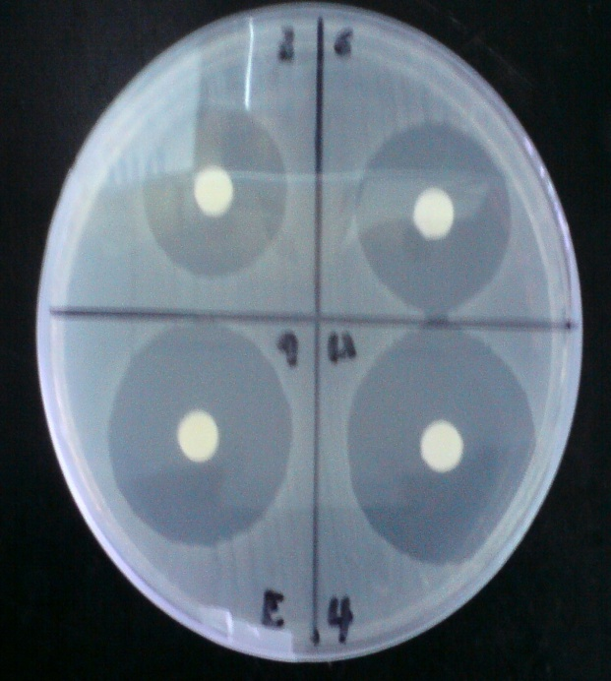

Figure 1: Antimicrobial activity of sample 4 against E.coli
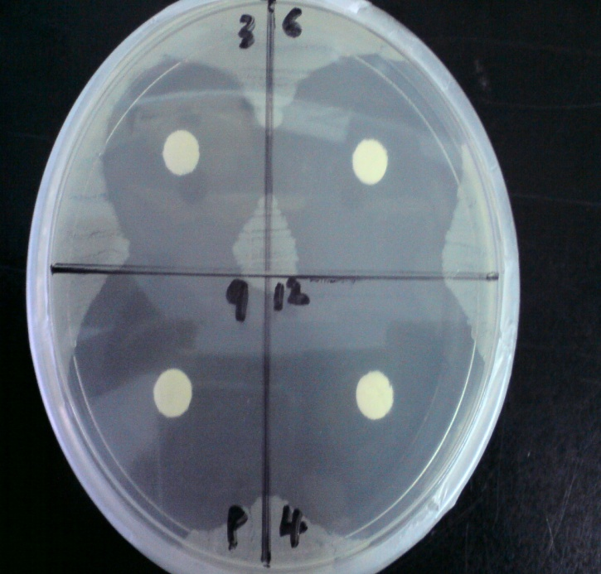

Figure 2: Antimicrobial activity of sample 4 against S.aureus
4. CONCLUSION
The current study describes the synthesis and antimicrobial activity of hexachloro cyclo triphosphazene based new compounds where on average compound 7 was found the most active on all the types of bacteria. This might be due to three Saccharino units bonded with P₃N₃Cl (Scheme 2).
5. REFERENCES
- W. Couldrıdge. Some interactions of nitrogen chlorophosphide, J.Chem.Soc. Trans. 53,398 (1888).
- H.N.Stokes. Ber.dtsch.chem.Ges.28, 437 (1895).
- A. Besson. C.R. hebd. Seances Acad. Sci.146,1149 (1908).
- R. Chenck; U.G. ROMER. Ber, dtsch. Chem..Ges.57B,1343 (1924).
- R. Chenck; U.G. ROMER. Ber, dtsch. Chem..Ges. 60,160 (1927).
- H.Moureu; P. Rocquet; A. M. De Frcquelmont; C. R. hebd. Seances Acad. Sci.198,1417 (1934).
- H.Moureu; P. Rocquet. C. R. hebd. Seances Acad,Sci.198, 1691(1934).
- A.M. Defıcquelmont.C.R.hebd.Seances Acad.Sci.200, 1045 (1935).
- A.M. Defıcquelmont.C.R.hebd.Seances Acad.Sci.202, 423 (1935).
- H. Moureu; P . Rocquet. C. R. hebd.Bull. Soc. Chim. France 3, 829 (1936).
- H. Rose. Ann. Chem. 11, 131 (1834).
- J. Liebig. Ann. Chem. 11, 139 (1834).
- J.H. Gladstone, J.D. Holmes. J. Chem. Soc. 17,225 (1864).
- H.R. Allcock, Chem. Rev. 72, 315 (1972).
- C.W. Allen, Chem. Rev. 91, 119 (1991).
- H.R. Allcock. Polyhedron 6, 119 (1987).
- P C.W. Allen. The Chemistry of Inorganic Homo- and Heterocycles, Academic Press, London, P.501, (1987).
- R. Schenk; G. Romer. Chem. Ber. B57, 1343 (1924).
- C. T. Laurencin; H. G. Koh; T. X. Neenan; H . R. Allcock; R. Langer, J. Biomed. Mater. Res. 21, 1231-1246 (1987).
- H. R. Allcock; S.R. Pucher; R.J. Fitzpatrick; K. Rashid. Biomaterials, 13, 857-862 (1992).
- G. Giavaresi; M. Tschon; V. Borsari; J.H. Daly; J.J. Liggat; M. Fini; V. Bonazzi; A. Nicolini; A. Carpi; M. Morra; C. Cassinelli; R. Giardino. Biomedicine and pharmacotherapy. 58, 411-417 (2004).
- Y.J. Jun; J.I. Kim, M.J. Jun; Y.S. Sohn, J. Inorg. Biochem. 99, 1593-1601 (2005).
- K. Brandt; R. Kryszynski; T.J. Bartczak; I.P. Czomperlik. Inorg. Chim. Acta.. 322, 138-144 (2001).
- Albright and Wilson Ltd. Brit. Pat. 1016642 (1966).
- Albright and Wilson Ltd. Brit. Pat. 1017375 (1966).
- R.N. Das; R.A. Shaw; B.C. Smith; M. Woods, J.Chem. Soc, Dalton Trans. 709 (1973).
- D.J. Lingley; R.A. Shaw; M. Woods; S.S. Krishnamurthy. Phosphorus Sulfur. 4, 379 (1978).
- S. Das; R. Keat; R.A. Shaw; B.C. Smith. J. Chem. Soc. 5032 (1965).
- N.V. Mani; A.J. Wagner. Acta Crystallogr. Sect. B 27, 51 (1971).
- M.J. Begley; D.B. Sowerby; T.T. Bamgboye. J. Chem. Soc., Dalton Trans. 1401 (1979).
- W. Polder; A.J. Wagner. Cryst. Struct. Commun. 5 253 (1976).
- D.D. Perrin; W.L.F. Armagedo. Purification of laboratory chemicals, 3rd ed.,perjamon press, oxford (1988).
- O. Yilmazet. Bioorganic chemistry. 30 303-314 (2002).
- H.R. Allcock; S.R. Pucker; R. J. Fitzpatrick. Biometerial. 13 857-863 (1992).
- J.H.L. Crommen; T.H. Schatcht; E.H.G. Mense. Biomaterial 13, 511-520 (1992).
- J.H.L. Crommen; T.H. Schatcht; E.H.G. Mense, Biomaterial 13, 601-611 (1992).
- E.M. Ruiz; C.A. Ramirez; M.A.A. ponte; G.V. Barbosa – Canovas. Biomaterial 14, 491-496 (1993).
- C.G. Cidester; J. Szmuszkovicz; D.J. Duchamp; L.G. Laurian; J.P. Freeman. Acta- cryst. c44, 1080 -1083 (1988).
- T. Oikawa; N. Kanomata; M. Tada. J.org. chem. 58, 2046-2050 (1993).
- J. Tang; J. Dopke; J.G. Verkade. J .Am . chem. Soc. , 115, 5015-5020 (1993).
- J. Kovacs; I. Pinter; M. Kajtar-Peredy; L. Somsak. Tetrahedron. 53, 15041-15050 (1997).

